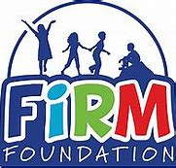
Creams, Lotions, Lip Balm, Sunscreen Etc.

Children are permitted to bring such items such as cream, lotions, lip balm, sunscreen, bug spray, etc. All items must be in its original packaging and labelled with the following:
- Child’s Name
- Expiry Date (if applicable)
- Special Care or Storage Instructions (if applicable)
- When and Where to Apply (if applicable)

I ___________________ (parent name), have read this document and agree to its terms.
- I authorize the educators at Firm Foundation to assist in the administration/application of these products to my child.
- By clicking this box, signifies that I agree to the information above being true and have completed the form myself.

Additional notes unable to fit on the label for these items:
_________________________________________________________________________________________________________________________________________________________________________________________________________________________________________________________________________________________________________________________________________________________

_____________________________ _____________________________
Parent Signature Date

